The addinFront() method is used to add songs to the front if the list

public void addinFront(String data) {  
  
 Node newNode = new Node(data);  
  
 newNode.next = head;  
 newNode.prev = null;  
  
 if (head != null)  
 head.prev = newNode;  
  
 head = newNode;  
  
}

THE insertEnd() method is used to add songs to the end of the playlist.

// add song at the end fo the playlist  
void insertEnd(String data) {  
  
 Node new_node = new Node(data);  
  
 Node temp = head;  
 new_node.next = null;  
  
 // if the linked list is empty, make the newNode as head node  
 if (head == null) {  
 new_node.prev = null;  
 head = new_node;  
 return;  
 }  
  
 // if the linked list is not empty, traverse to the end of the linked list  
 while (temp.next != null)  
 temp = temp.next;  
  
 temp.next = new_node;  
  
 new_node.prev = temp;  
}

Inside the app the user makes a choice of what action they would like to perform.

The input is then taken to a switch statement which the appropriate code is run depending on the user’s selection

To add a song to the front of the list would be choice 1, and to add a song to the end of the list would be choice 2.

The user adds 3 songs to the playlist

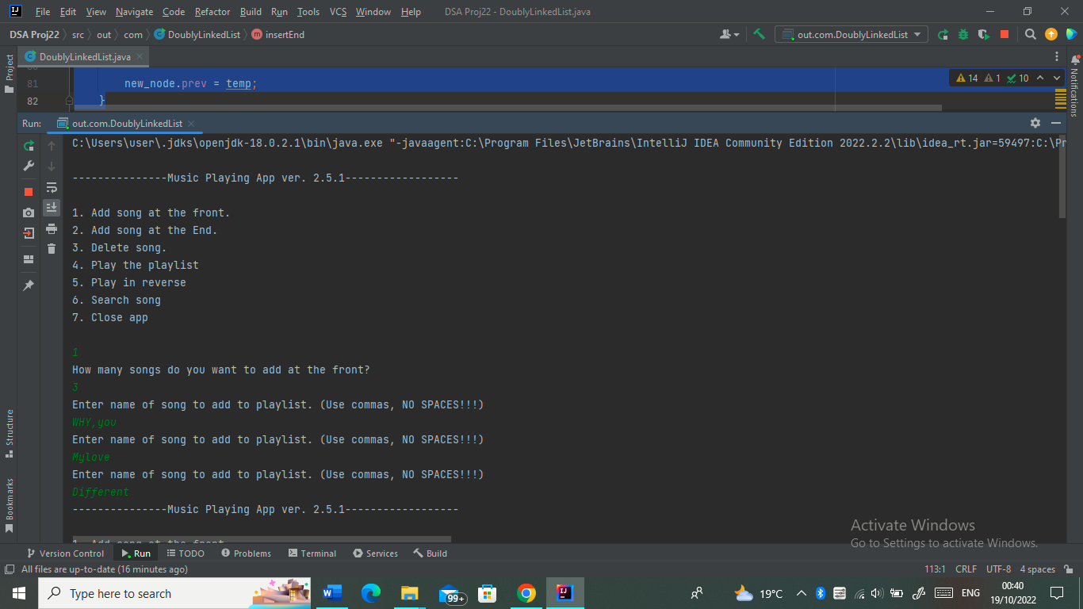

The playlist after adding the 3 songs

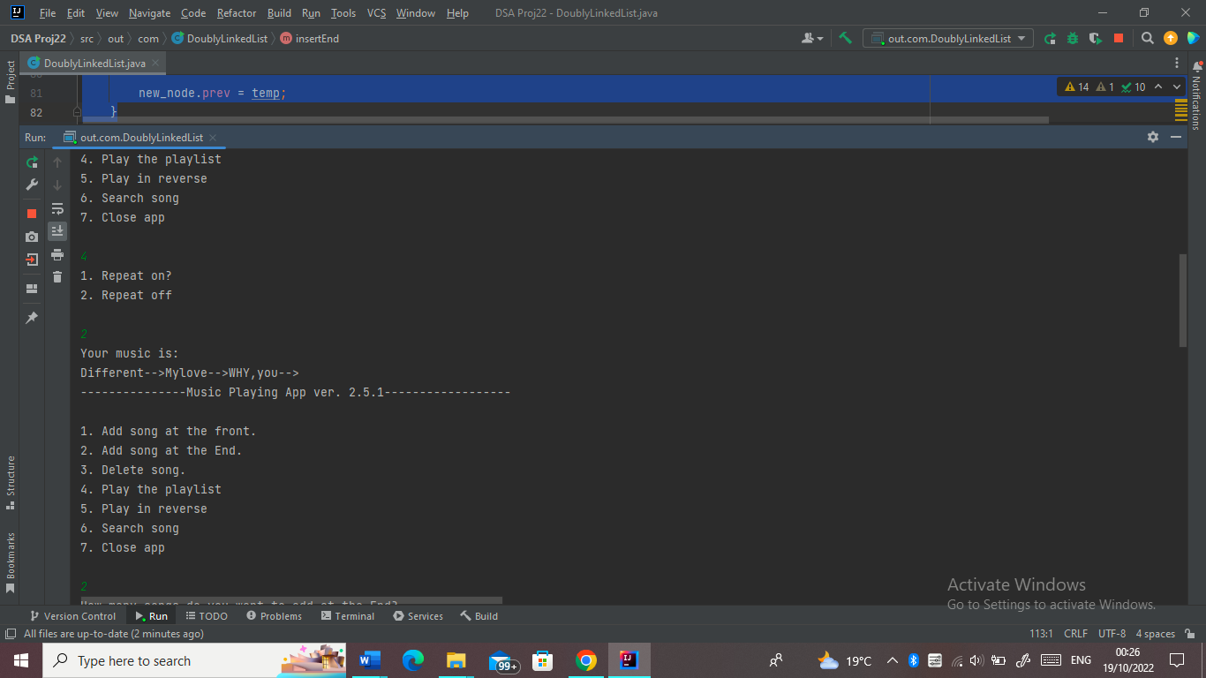

The user is able to add songs to the end of the playlist

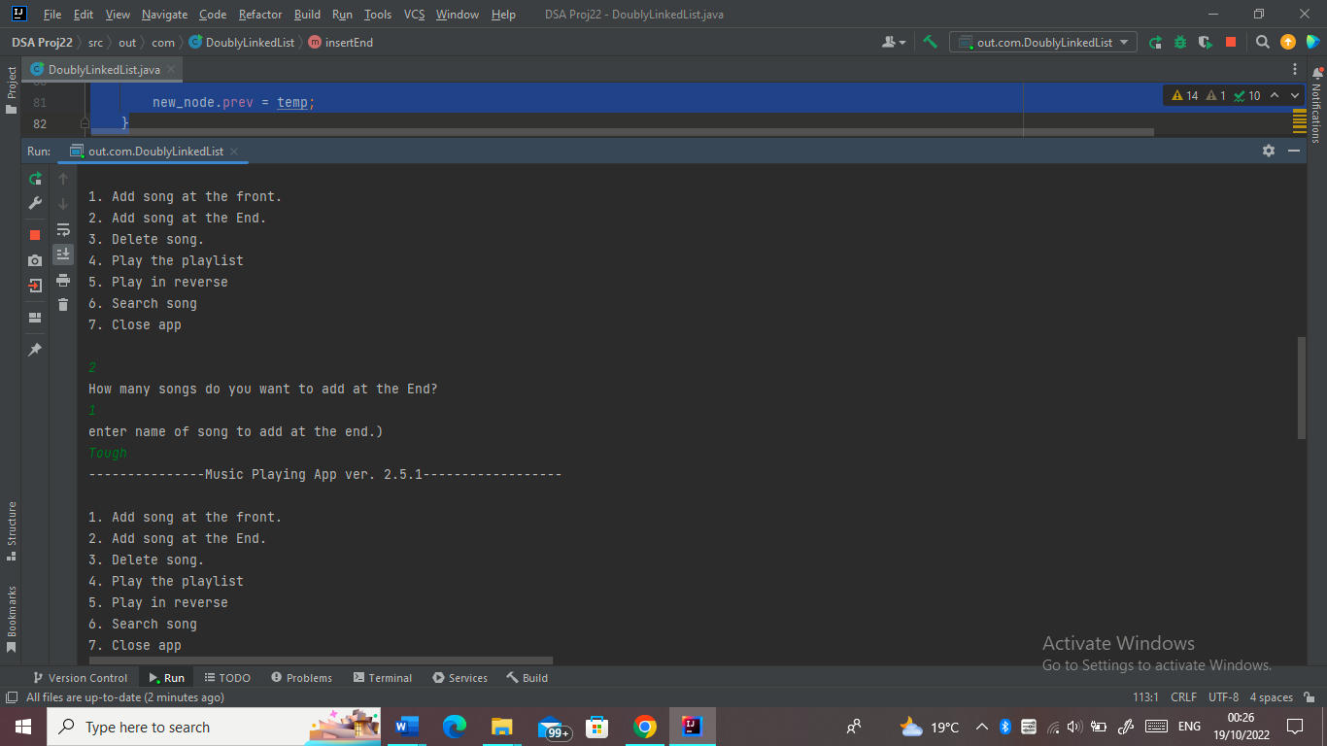

The playlist after the song Tough is added at the end

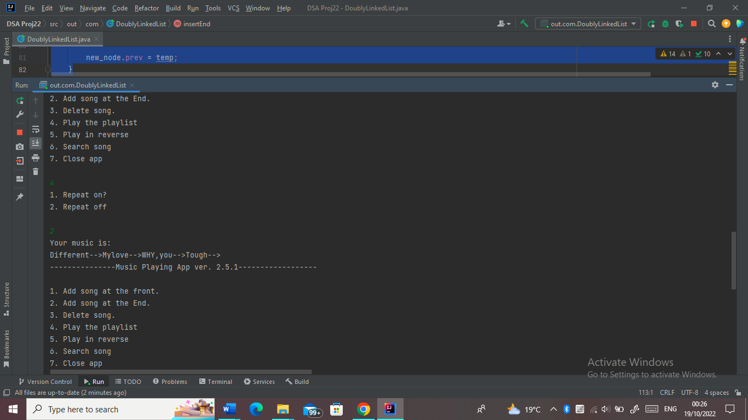

The user is able to add songs to the fornt of the playlist

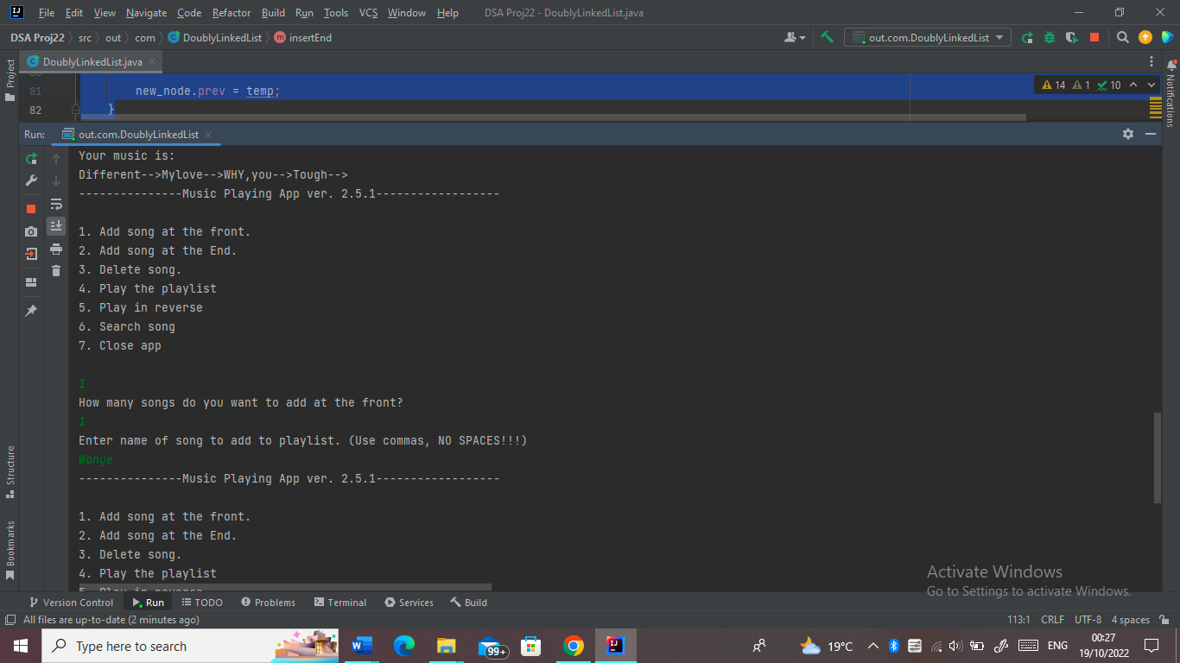

The song ,Wanye, after being added to the front of the list

